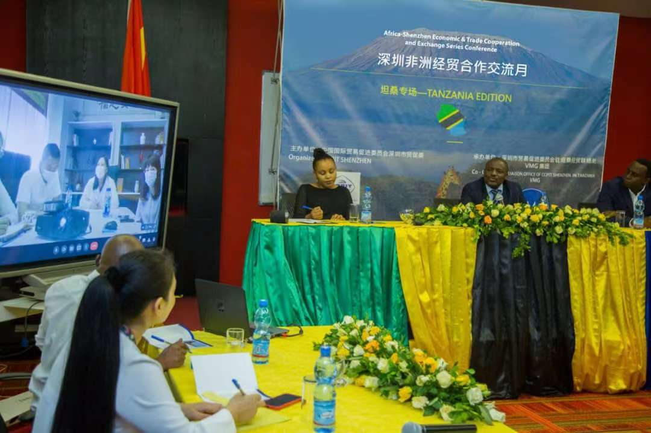
Africa-Shenzhen Economic & Trade Cooperation and Exchange Series
Conference – Dar es Salaam, Tanzania. 31 August, 2021.
In recent days the sixth phase government has been putting in place a great efforts in achieving the goal of realizing an industrialized economy country, this government's commitment has been manifested after many investors expressed interest in investing in Tanzania in various sectors including manufacturing sector. This is a proof that the government's efforts are beginning to bear fruit, despite the fact that local investors have increased in number, even statistics show that many foreign investors have expressed their interest in investing in Tanzania.
As these efforts continue, Recently Vipawa Management Group (VMG) has successfully held a business meeting of its kind between the Chinese Council for the Promotion of International Trade in Shenzhen and Export Processing Zones Authority (EPZA)
The meeting aims to develop business and trade relations between China and Tanzania. Chinese people intend to promote the mutual understanding and friendship between the two countries in line with law and government policies.
At the meeting held on August 31, 2021 in Dar es Salaam; China Council for the Promotion of International Trade Shenzhen (CCPIT Shenzhen) expressed interest to be informed on opportunities available in Agriculture, Mining, Tourism, Trade and Industry and wanted to know how Tanzania serves investors interested in investing in various sectors.
Acting Director General of Export Processing Zones Authority (EPZA), John Mnali attended the online business meeting where he gave a presentation contained sufficient information about the investment climate in Tanzania, He also explained all the procedures to be considered in establishing investment projects in Tanzania such as the criteria and conditions to be followed during registration stage. Also the director explained in detail all the things that stakeholders wanted to know including business opportunities available in Tanzania.
After explaining in detail the investment opportunities available through EPZA, Acting Director General, explained that in Tanzania there are three institutions responsible for promotion and facilitation of investments in Tanzania, these institutions are Export Processing Zones Authority (EPZA) which is specifically for industries that plan to produce for the export market, Tanzania Investment Center (TIC) which accommodates all sectors with exception of Mining, and Oil &gas projects. In Zanzibar, there is Zanzibar investment Promotion Authority (ZIPA) which oversees all investment opportunities in the islands of Zanzibar.
Mr. Mnali said that under EPZA, the investor can be registered through the EPZ or SEZ scheme. To qualify for EPZ license, the investor is required to be able to export at least 80% of the products he produces, it must also be a processing plant and ultimately its exports should not be less than $ 500,000 per annum for a foreign investor and $ 100,000 per annum for a local investor.
Also he explained that there are various fiscal and non fiscal incentives for all investors who can invest through the EPZA Scheme, and the government through EPZA has established a One Stop Service Center (OSSC), which accommodates representatives from all key institutions including Tanzania Revenue Authority, Labor and Migration. Through OSSC, EPZA officials will ensure that investors have access to all other service providers as well as networking the investors with key stakeholders to achieve the intended investment goals. Mr. Mnali explained that through the EPZ license, the investor is allowed to import machinery, production equipment and any other capital goods related to EPZ investment without paying any taxes and duties.He also explained that an investor using an EPZ license will not pay VAT on all raw materials he buys for the purpose of producing export products, also VAT on utilities have been completely waived to reduce production costs.
Other benefits of investing through EPZA he said are that the investor will do business freely, unconditional transferability of the net profit, payments of foreign loans, payment of Royalties, and fees.
Explaining on existing investment opportunities, Mr. Mnali said, "Currently the government's goal is to find investors who can invest heavily in agricultural sector and add value to pre-export crops in order to avoid selling raw produce.He also mentioned that there is a great opportunity to invest in the production of edible oil, because the capacity to produce crops such as sesame, sunflower and palm oil is great, so we invite various investors in this important sector, as the market for edible oil is large domestically and abroad
In addition to processing edible oil, Mr. Mnali explained that there is a huge opportunity in the cultivation of avocado as this product has a market that is global and is in great demand in various places. Mr. Mnali mentioned various areas where the avocado crop thrives including Moshi, Arusha, Mbeya and Njombe. He also mentioned that another opportunity exists in horticultural crops which Tanzania produces in large quantities as well
He also added that value addition is not limited to agricultural products but to all other Sectors such as mining, timber products, honey, leather, textile, livestock, fisheries and meat
Giving additional information on the mining sector, Mr. Mnali said that the sector contributes significantly to Tanzania's economic growth, apart from processing minerals, there is an opportunity to build hotels of different status, entertainment Centre’s and hospitality for tourists.

In Trade and Industry Mr. Mnali said there is a lot to do in the manufacturing sector as many manufactured products that are used in the country are imported including, medicine and medical equipment.

In addition to those opportunities, Mr. Mnali mentioned other opportunities in the forestry sector, such as timber harvesting and processing into wood and wood related products, he finally mentioned investment opportunities in fishing from lakes and sea that these opportunities are open to investors.

After a good presentation from Acting EPZA Director General, John Mnali. CCPIT Shenzhen expressed great satisfaction with the opportunities and incentives offered by the country and promised that China will take advantage of investing in Tanzania in the near future, also a CCPIT representative noted that Tanzania is very popular in China for the existence of the tallest mountain in Africa (Mount Kilimanjaro), Zanzibar Islands and beautiful natural beaches.

